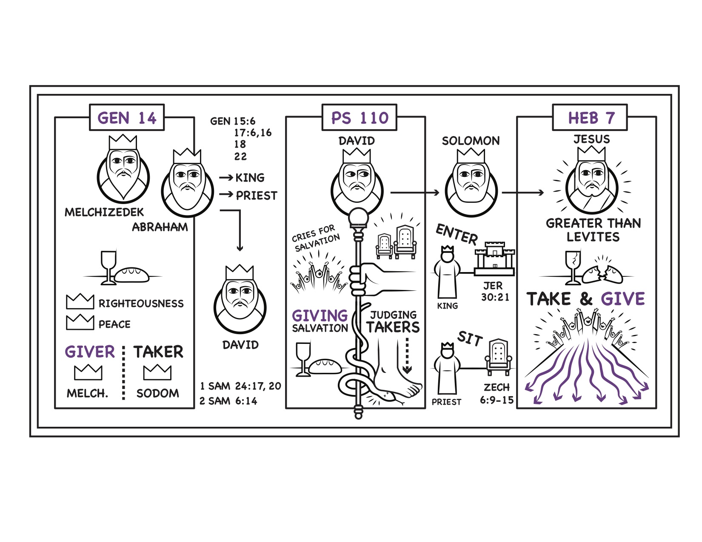
A Priest Like Melchizedek
Genesis 14:17–24; Psalm 110:1–7; Hebrews 7:1–28

Notes on Melchizedek
Genesis 14 | Psalm 110 | Hebrews 7

